

**PROJECT-1**

**Name:** Chandra sekhar

**Course:** Aws, Devops

**Project:** Aws 3- tier Architecture

**Mobile:** 8367284683

**Email:** sc637880@gmail.com

**INTRODUCTION OF 3-TIER ARCHITECTURE**

The three-tier architecture is the most popular implementation of a multi-tier architecture and consists of a single presentation tier (or) web tier, Application tier (or) logic tier, and database tier.

Presentation Tier: Its main purpose is to display information to and collect information from the user.

Application Tier: Information that is collected in the presentation tier is processed - sometimes against other information in the data tier. The application tier can also add, delete, or modify data in the data tier.

Database Tier: The data tier, sometimes called database tier, data access tier or back-end, is where the information that is processed by the application is stored and managed.

Benefits of 3-Tier Architecture: Scalability, Reliability, Security, Flexibility.

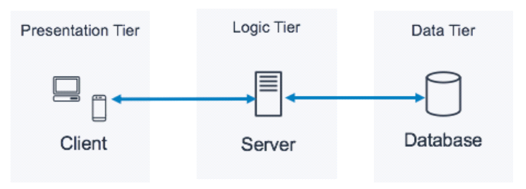

**ARCHITECTURE:** 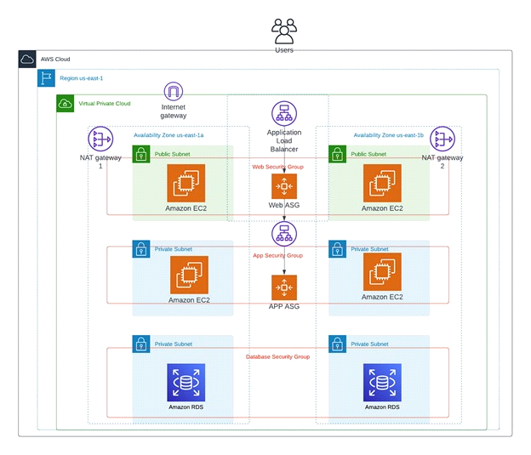

VPC stands for virtual private cloud,it gives you full control over your virtual networking environment, including resource placement, connectivity, and security

The puspose of VPC is a secure, isolated private cloud hosted within a public cloud.

* Creating a VPC and its components
* VPC components:

1.subnets-> public, private

2.internet gateway

3.route Tables

4.NAT gateway

* Using above architecture we need to create a VPC and 2 public subnets in 2 availability zones and 4 private subnets in 2 availability zones
* Login to the AWS management console and in search bar search VPC
* Click on VPC and Create VPC
* Select vpc only and give name
* Enter the IPV4 CIDR
* Click on create VPC

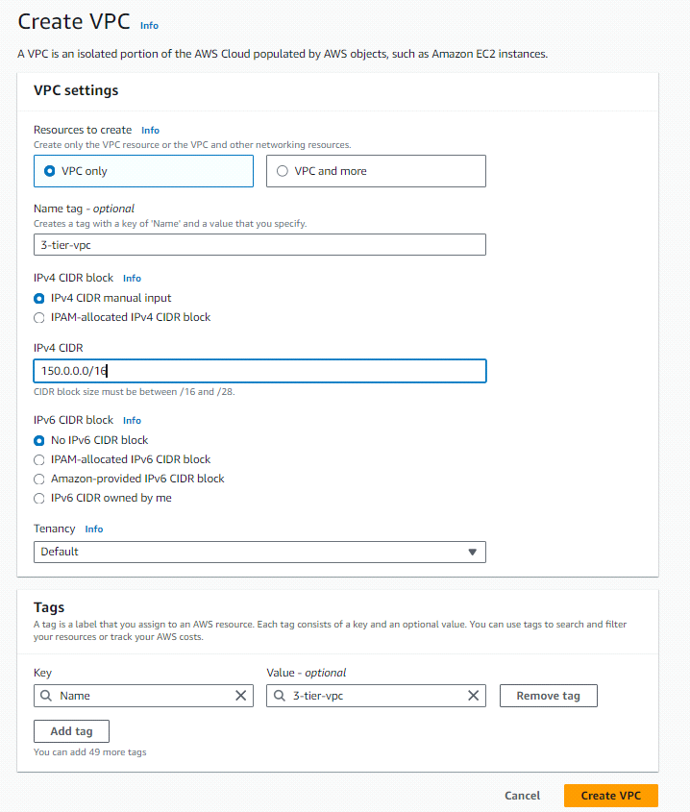

* Here VPC is successfully created

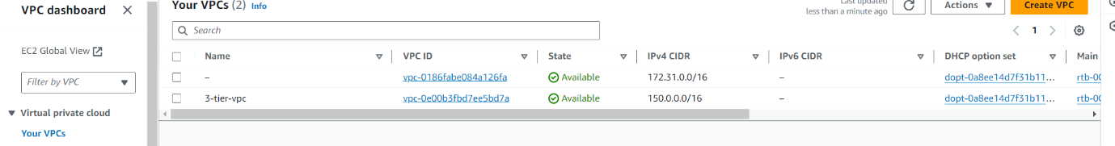

A subnet is a range of IP addresses in your VPC. You launch AWS resources, such as Amazon EC2 instances, into your subnets. You can connect a subnet to the internet, other VPCs and your own data centers.

* We need to create 6 subnets, that are 2 public subnets in 2 zones and 4 private subnets, 2 private subnets are 1a zone for autoscalling, another 2 private subnets are 1b zone for database
* Go to subnets and click on create subnets
* Select your VPC, in subnet settings give subname
* Select availability zone and give IPV4 VPC CIDR block
* Now click on Add subnets
* Click on add subnets we have to carete 5 more subnets
* Click on create subnets

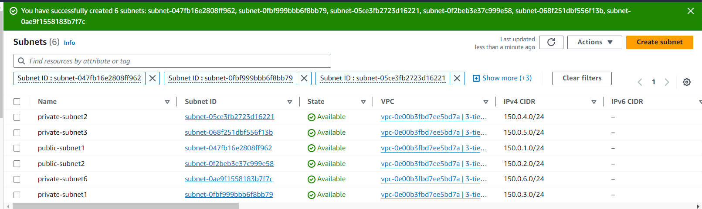

Internet gateways provides two-way ublic connectivity to applications running in Aws Regions or in Local Zones.it is used to enables you to connect to an EC2 instance in AWS using your local computer.

* Next we need to create one internet gateway
* Click on create internet gateway and attach to your VPC to internet gateway

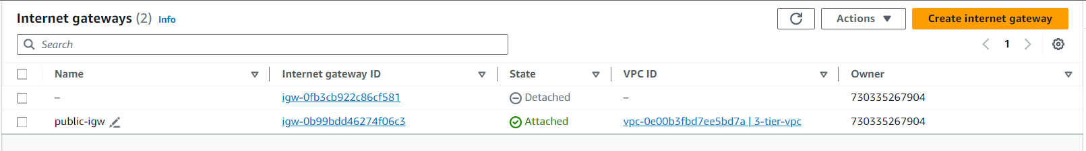

NAT stands for Network Address Translator. It is a highly available AWS managed service that makes it easy to connect to the Internet from instances within a private subnet in an Amazon VPC.

* According to 3-tier architecture we need to create two NAT gateways
* NAT gatewa
* Create NAT gateway and give the name, select your public subnet
* Click on Allocate Elastic IP now you can create your NAT gateway

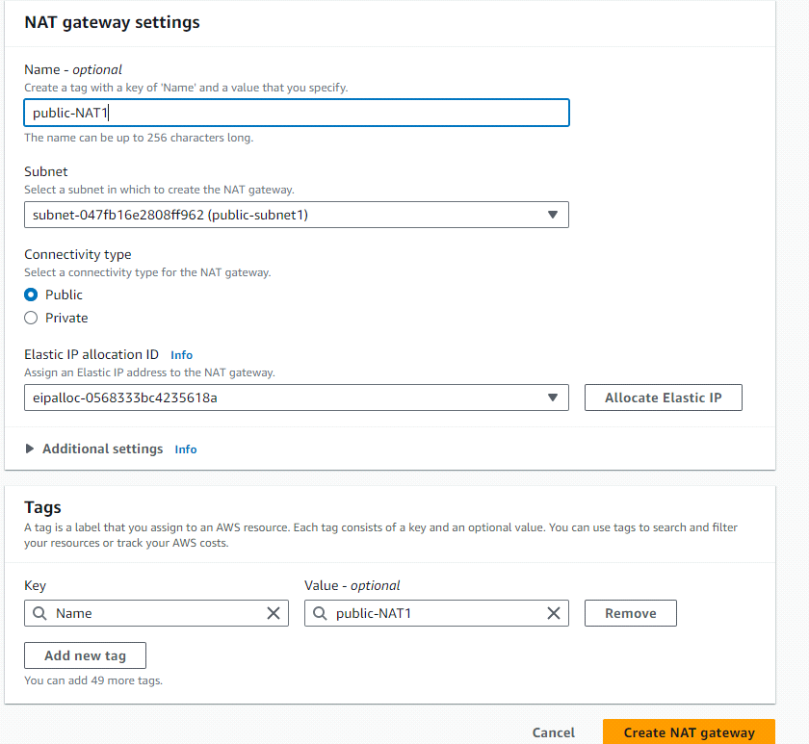

* Also create one more NAT gateway, select public subnet2
* Click on create NAT gateway

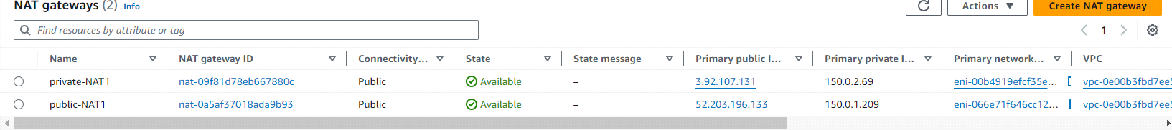

A route table contains a set of rules, called routes, that determine where network traffic from your subnet or gateway is directed.it is used to determine which way to forward traffic.

* Create 3 route tables,1 is for public subnets, next one is private subnets and next one is database subnets
* Give the name and select your VPC
* Click on create route table
* Create 2 more route tables

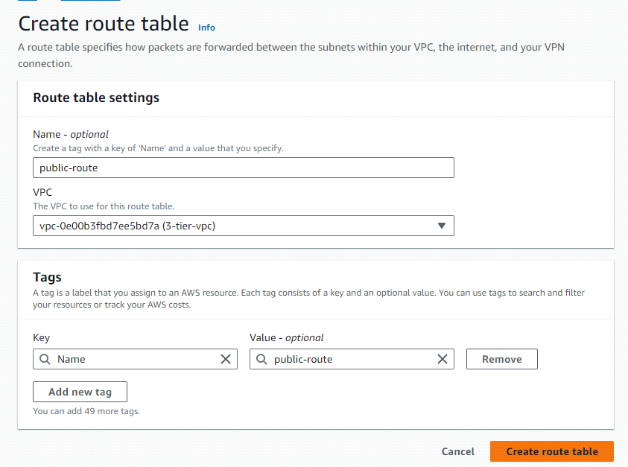

* Select public route table and go to actions
* Click on edit routes and add routes
* Attach internet gateway and click on save changes
* Now go to subnet associations and click on edit subnet associations
* Select public subnets and click on save changes
* For private rote tables you can attach NAT gateways

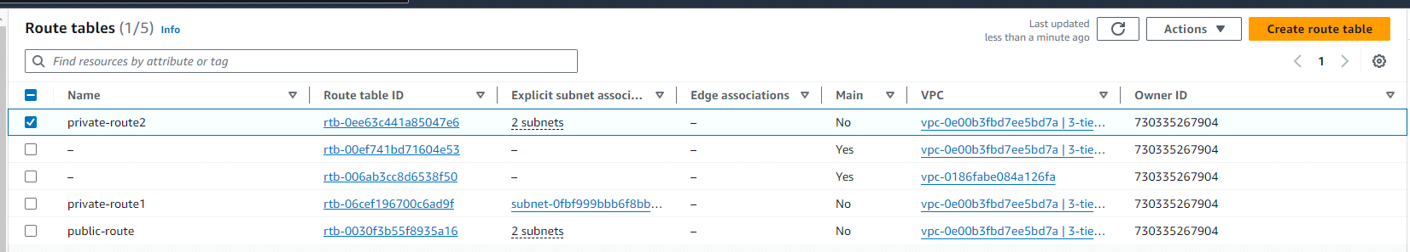

* Go to Ec2 now you have to launch 2 instances manually
* Click on launch instance and give the naming and create key pair
* Edit network settings, select your VPC and subnet
* Ebable Auto-assign public IP
* Create security group,creation of security group you have to add security groups i.e HTTP,MYSQL/Aurora
* Now click on launch instance

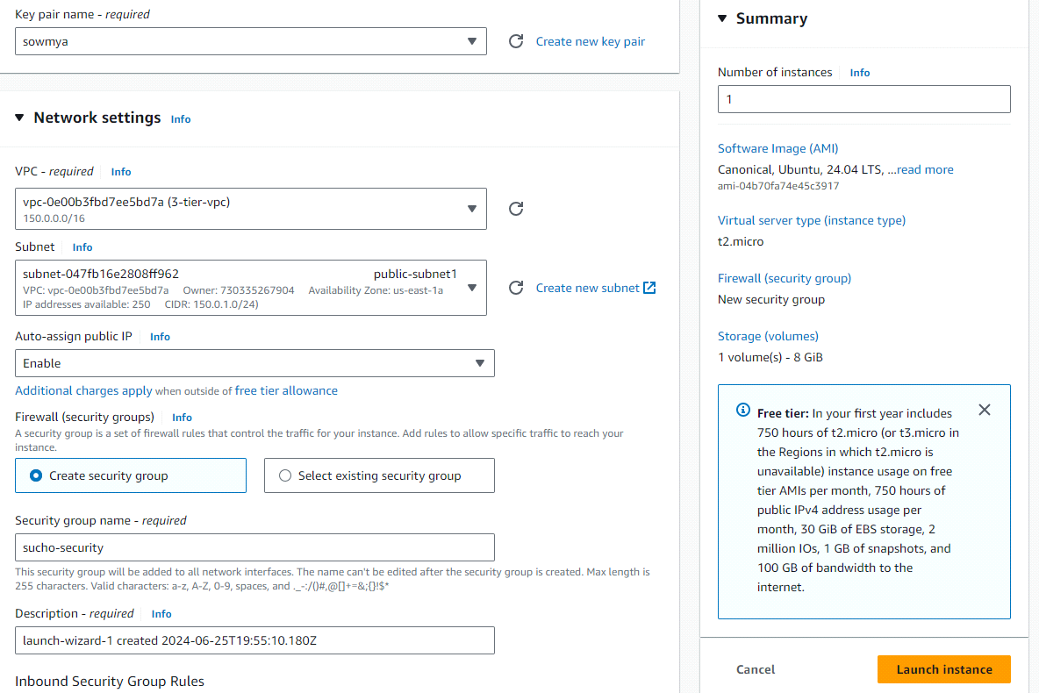

* Now you to create launch Template
* Select your instance go with image and templates
* Click on create template from instance
* Give naming and create launch template

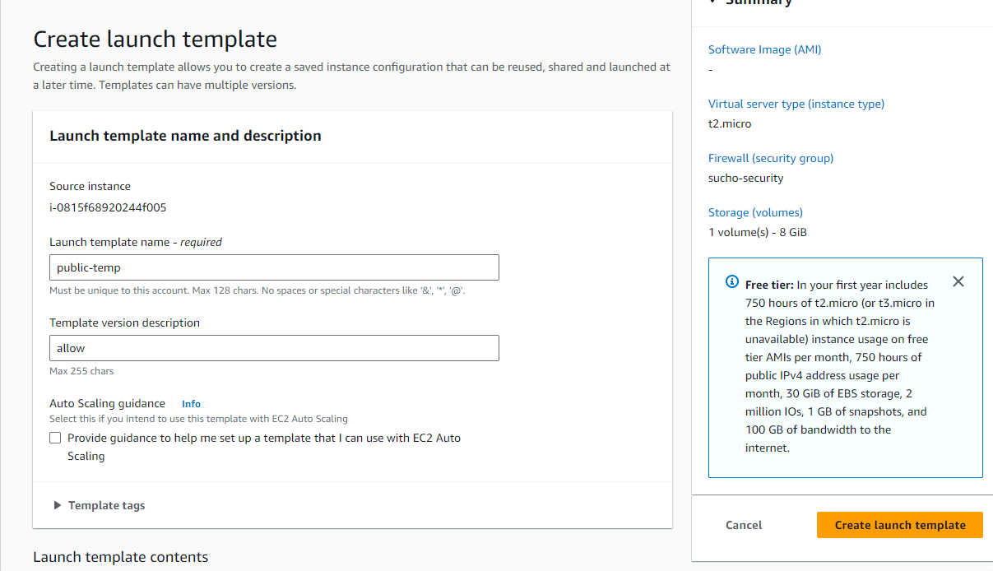

* Create Target group and clik on it
* Give the name and choose your VPC nad click on next
* Select your instance ,click on create Target group

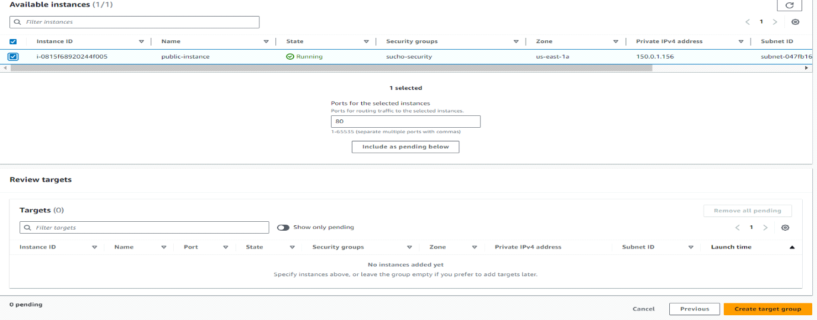

Load balancer distribute incoming application traffic across multiple targets, such as Ec2 instance, in multiple availability Zones

* Now create load balancer and go with Application load balancer
* Give name and choose your VPC, In mappings select public subnets
* select your security group and also select Target group
* click on create load balancer

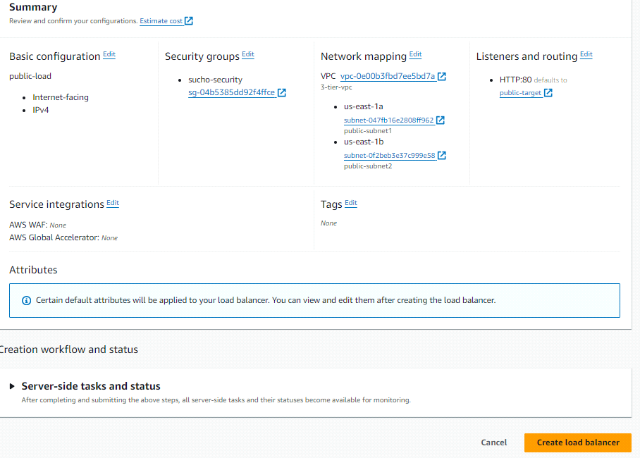

* Now go to Ec2 service and select Auto Scaling group.
* Click on Create Auto Scaling group.
* Give name tag Auto Scaling group name for public.
* Select your public launch template and click on next
* In network settings select your VPC and select two public subnets click on next
* In configure group size and scaling enter desired capacity, click on next
* click on create Auto scaling

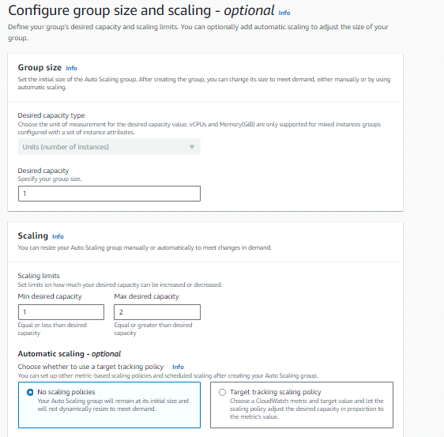

* Same as it is, you need launch another instance whic is "private"

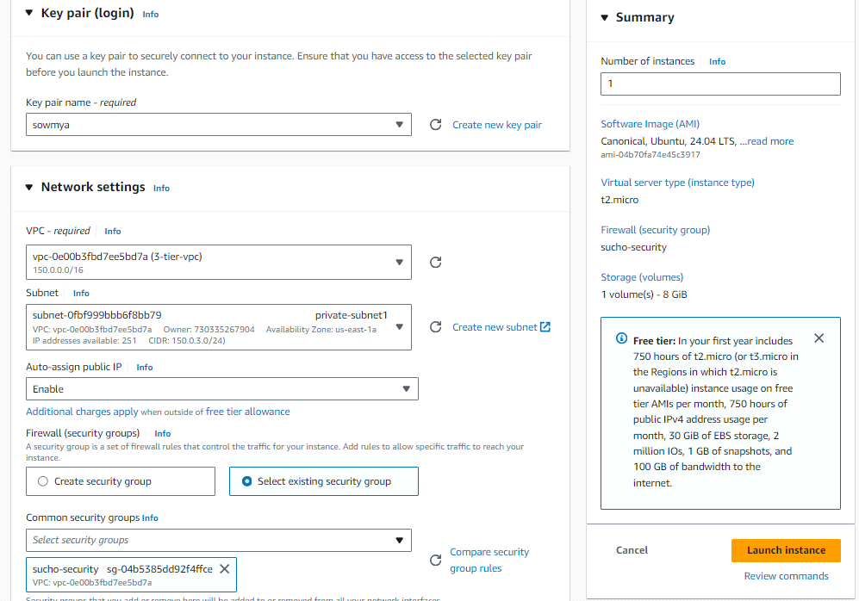

* Create another template "private" and attach to private instance

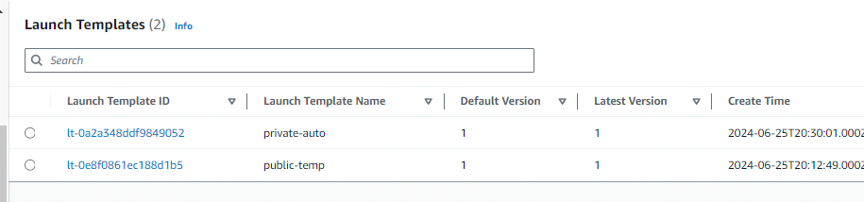

* Create another Target group "private"

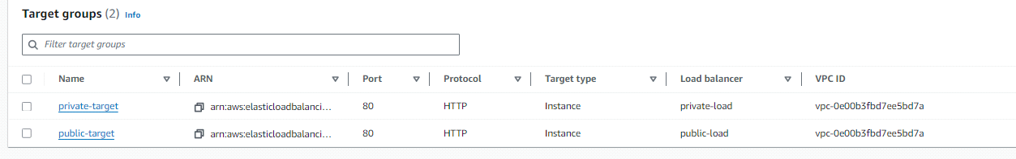

* Create another load balancer "private"

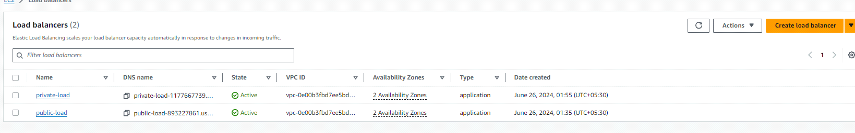

* Create another Auto-scaling
* Attach private subnets 2

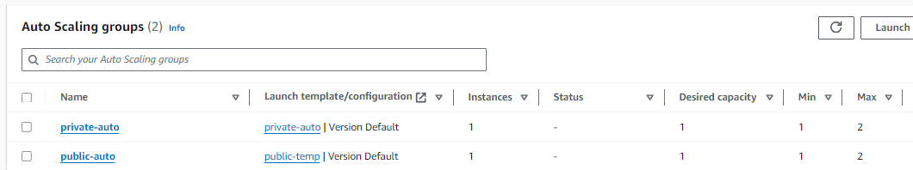

RDS stands for Relational database service and it is an easy-to-manage relational database service optimized for total cost of ownership.

RDS DB subnet group is a collection of subnets that are associated with an Elastic Compute Cloud(Ec2) and Virtual private cloud(VPC).

* Now go to search bar and search RDS
* Now you need to create subnet group
* An RDS Subnet Group is a collection of subnets that you can use to designate for your RDS database instance in a VPC.
* Click on create subnet group and enter the name, choose your VPC

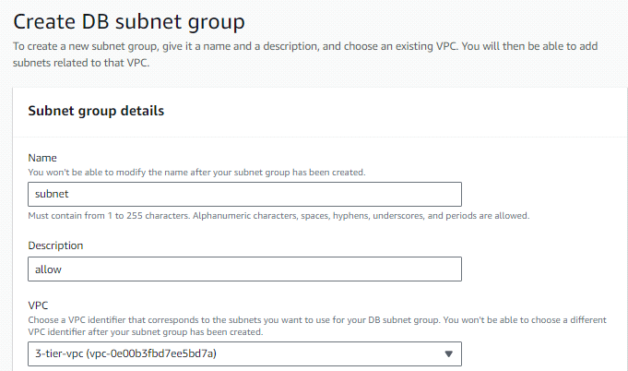

* Select your Availability Zones
* Add subnets using private subnets and select private subnets
* Click on create

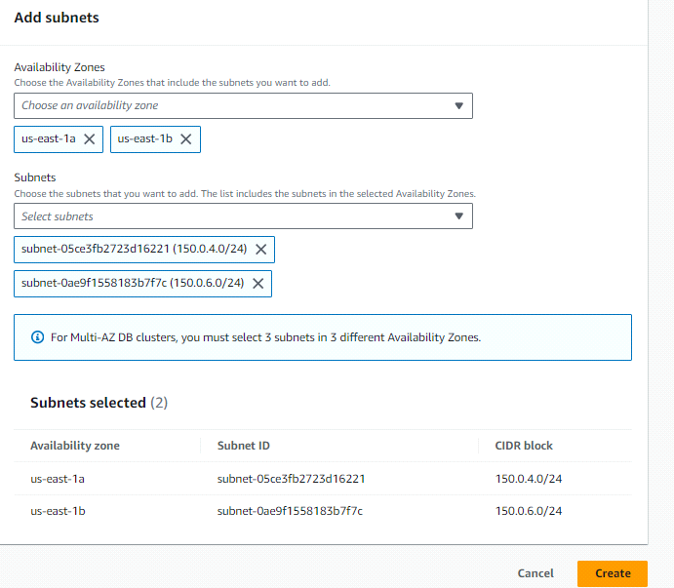

* Go to database and click on create database
* Select a database creation method is "standard create"
* Select MYSQL engine type and select free tier template
* Enter name for your DB cluster and enter master username
* Select credentials management is "slef managed" and enter your own password
* In connectivity slect your VPC and security group and click on create database.
* Go to ec2 instance click on public instance and connnect it
* Now in public instance you have to connect private instance

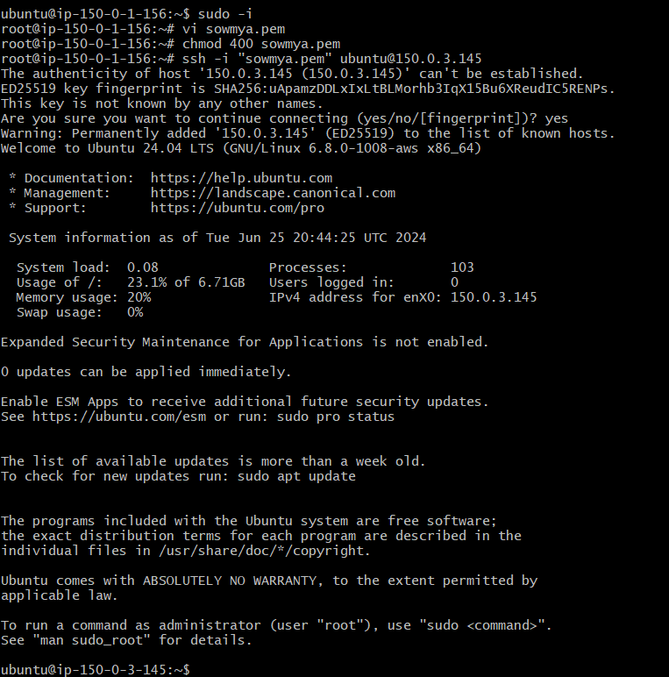

* You have install MYSQL
* First you need update for that enter "apt update -y"
* To install MYSQL enter the command is "apt install mysql-server"
* To start the MYSQL enter the command is "systemctl start mysql.service"
* To connect database enter the command is mysql -h <paste database endpoint> -u <master username> -p
* Enter your password
* So finally SQL server is connected

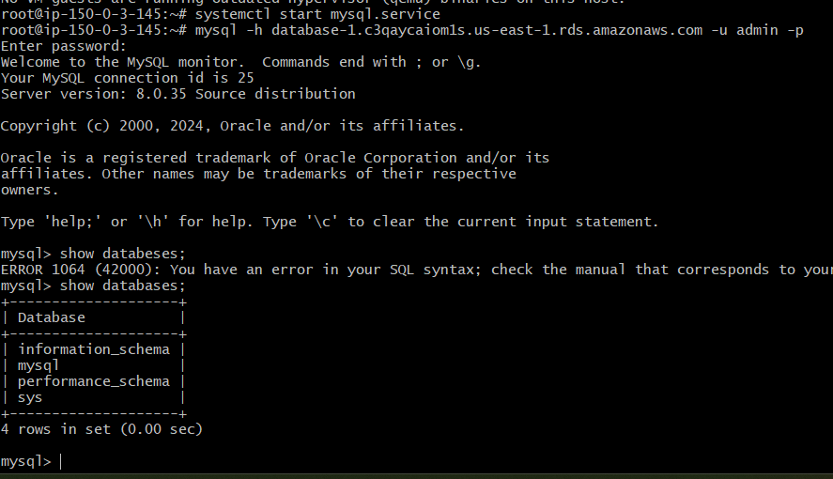

conclusion: 3-tier architecture provides a robust and scalable approach to building modern applications. By dividing an application into presentation, application, and data layers.we successfully designed and implemented a scalable ,secure, and efficient 3-tier architecture in amazon web services for web applications.